Name: Mriganka Patra

Email: [mriganka.patra@cognizant.com](mailto:mriganka.patra@cognizant.com)

Emp ID: 2415820

Day 18

Sprint 1 Submission

Task 1.2: As a CRM user, I want to see the age of a contact calculated from their birthday so that I can segment users by age group.

1. Select Contact Object
2. 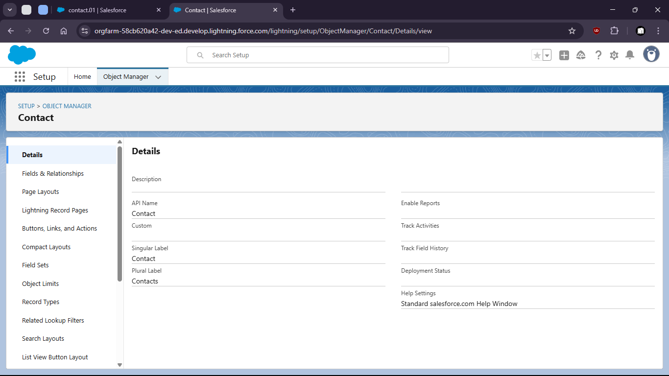
3. Create new field Age (number)